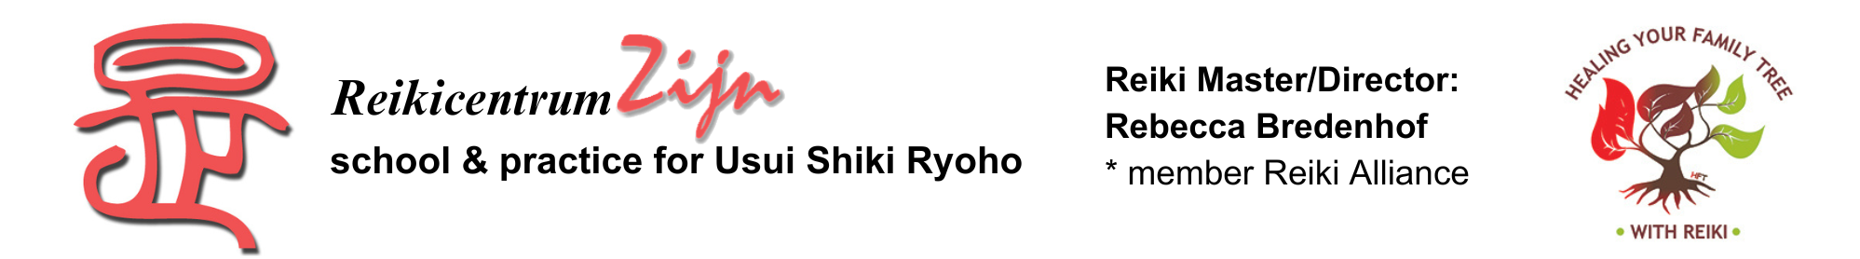

REGISTRATION

Healing your Family Tree with Reiki (HFT)
with Rebecca Bredenhof
from 2nd Degree

Friday 21 until Sunday 23 February and Friday 4 until Sunday 6 april 2025
Location: The Hague

First and last name:

Adress:

Zip code and residence :

Telephone: Mobile:

Email adress:

2nd Degree student or Reiki master?

Practical information

Investment: € 950,- for 2 weekend workshops and 6 weeks of personal guidance
Language: Dutch (interpretation to English is possible)
* I need translation into English, so I make a separate donation of € 100,- or more to the same bank account: 0 Yes - 0 No

Payment:
- If you have an IBAN account, you can transfer the full amount to NL62 ABNA 0885 3321 21
att. R. Bredenhof, The Hague. Subject: ‘HFTmrt/apr2024’ (BIC: ABNANL2A).

- If you have no IBAN account, you can transfer the full amount to my PayPal account (reikicentrum.zijn@hetnet.nl); I really appreciate it if you cover the PayPal costs.

Date: Signature:

Please email this form to the organizer::
Mirjam Top-Termaat, 06 81 42 95 78 / reikitwente@hotmail.com
We can send you an address list of B&B’s and hotels in the area.

